

**Department of Computer Science**

**Lab Manual**

**of**

**SPEECH PROCESSING AND RECOGNITION**

**MAI574**

**Class Name: V MScAIML**

**Master of Science Artifitial Intelligence and Machine Learning**

**2025-26**

**Prepared by:Nigazhvan Verified by: Faculty name:**

**Department Overview**

Department of Computer Science of CHRIST (Deemed to be University) strives to shape outstanding computer professionals with ethical and human values to reshape nation’s destiny. The training imparted aims to prepare young minds for the challenging opportunities in the IT industry with a global awareness rooted in the Indian soil, nourished and supported by experts in the field.

**Vision**

The Department of Computer Science endeavours to imbibe the vision of the University “**Excellence and Service”**. The department is committed to this philosophy which pervades every aspect and functioning of the department.

**Mission**

“To develop IT professionals with ethical and human values”. To accomplish our mission, the department encourages students to apply their acquired knowledge and skills towards professional achievements in their career. The department also moulds the students to be socially responsible and ethically sound.

**Introduction to the Programme**

Machines are gaining more intelligence to perform human like tasks. Artificial Intelligence has spanned across the world irrespective of domains. MSc (Artificial Intelligence and Machine Learning) will enable to capitalize this wide spectrum of opportunities to the candidates who aspire to master the skill sets with a research bent. The curriculum supports the students to obtain adequate knowledge in the theory of artificial intelligence with hands-on experience in relevant domains with tools and techniques to address the latest demands from the industry. Also, c andidates gain exposure to research models and industry standard application development in specialized domains through guest lectures, seminars, industry offered electives, projects, internships, etc.

**Programme Objective**

● To acquire in-depth understanding of the theoretical concepts in Artificial Intelligence and Machine Learning

● To gain practical experience in programming tools for Data Engineering, Knowledge Representation, Artificial intelligence, Machine learning, Natural Language Processing and Computer Vision.

● To strengthen the research and development of intelligent applications skills through specialization based real time projects.

● To imbibe quality research and develop solutions to the social issues.

Programme Outcomes:

PO1 : Conduct investigation and develop innovative solutions for real world problems in industry and research establishments related to Artificial Intelligence and Machine Learning PO2 : Apply programming principles and practices for developing automation solutions to meet future business and society needs.

PO3 : Ability to use or develop the right tools to develop high end intelligent systems

PO4 : Adopt professional and ethical practices in Artificial Intelligence application development

PO5 : Understand the importance and the judicious use of technology for the sustainability of the environment.

**MAI574– SPEECH PROCESSING AND RECOGNITION**

**Total Teaching Hours for Semester: 75 (3+4)**

**Max Marks:150                         Credits: 5**

**Course Objectives**

This course enables the learners to understand fundamentals of speech recognition, speech production and representation. It also enables the learners to impart knowledge on automatic speech recognition and pattern comparison techniques. This course helps the learners to develop automatic speech recognition model for different applications.

**Course Outcomes**

**After successful completion of this course students will be able to**

CO1: Understand the speech signals and represent the signal in time and frequency domain.

CO2: Analyze different signal processing and speech recognition methods.

CO3: Implement pattern comparison techniques and Hidden Markov Models (HMM)

CO4: Develop speech recognition system for real time problems.

**Unit-1         Teaching Hours: 15**

**FUNDAMENTALS OF SPEECH RECOGNITION**

Introduction- The Paradigm for Speech Recognition- Brief History of speech recognition research- The Speech Signal: The process of speech production and perception in human beings- the speech production system- representing speech in time and frequency domain- speech sounds and features.

**Lab Programs:**

1. Implement the task that takes in the audio as input and converts it to text.
2. Apply Fourier transform and calculate a frequency spectrum for a signal in the time domain.

**Unit-2                 Teaching Hours: 15**

**2.1 APPROACHES TO AUTOMATIC SPEECH RECOGNITION BY MACHINE:**

The acoustic phonetic approach-The pattern recognition approach-The artificial intelligence approach.

**2.2 SIGNAL PROCESSING AND ANALYSIS METHODS FOR SPEECH RECOGNITION:**

Introduction- spectral analysis models- the bank of filters front end processor- linear predictive coding model for speech recognition- vector quantization.

**Lab Programs:**

3. Implement sampling and quantization techniques for the given speech signals.

4. Explore linear predictive coding model for speech recognition

**Unit-3         Teaching Hours: 15**

**PATTERN COMPARISON TECHNIQUES**

Speech detection- distortion measure- Mathematical consideration- Distortion measure – Perceptual consideration- Spectral Distortion Measure- Incorporation of spectral dynamic feature into distortion measure- Time alignment and normalization.

**Lab Programs:**

1. Demonstrate different pattern in the given speech signal
2. Implement time alignment and normalization techniques

**Unit-4         Teaching hours: 15**

**THEORY AND IMPLEMENTATION OF HIDDEN MARKOV MODELS:**

Introduction- Discrete time Markov processes- Extension to hidden Markov Models- Coin - toss models- The urn and ball model- Elements of a Hidden Markov Model- HMM generator of observation- The three basic problems for HMM’s- The Viterbi algorithm- Implementation issues for HMM’s.

**Lab Programs:**

7. Implement simple hidden Markov Model for a particular application.

8.Apply Viterbi dynamic programming algorithm to find the most likely sequence of hidden states.

**Unit-5         Teaching Hours: 15**

**TASK ORIENTED APPLICATION OF AUTOMATIC SPEECH RECOGNITION:**

Task specific voice control and dialog- Characteristics of speech recognition applications- Methods of handling recognition error- Broad classes of speech recognition applications- Command and control applications- Voice repertory dialer- Automated call-type recognition- Call distribution by voice commands- Directory listing retrieval- Credit card sales validation.

**Lab Programs:**

9. Demonstrate automatic speech recognition for Call distribution by voice commands.

10. Apply speech recognition system to access telephone directory information from spoken spelled names (Directory listing retrieval).

**Text Books and Reference Books**

[1] Fundamentals of Speech Recognition, Lawrence R Rabiner and Biing- Hwang Juang. Prentice-Hall Publications, 20209.

[2] Introduction to Digital Speech Processing, Lawrence R. Rabiner, Ronald W. Schafer, Now Publishers, 2015.

**Essential Reading / Recommended Reading**

1. Intelligent Speech Signal Processing, Nilanjan Dey, Academic Press, 2019.
2. Speech Recognition-The Ultimate Step-By-Step Guide, Gerardus Blokdyk, 5STARCooks,2021.
3. Automatic Speech Recognition- A Deep Learning Approach, Dong Yu, Li Deng, Springer-Verlag London, 2015.

**Web Resources:**

1. [www.w3cschools.com](http://www.w3cschools.com)
2. <https://www.simplilearn.com/tutorials/python-tutorial/speech-recognition-in-python>
3. <https://realpython.com/python-speech-recognition/>
4. <https://cloud.google.com/speech-to-text/docs/tutorials>
5. <https://www.coursera.org/courses?query=speech%20recognition>
6. <https://pylessons.com/speech-recognition>

CO – PO Mapping

|  | PO1 | PO2 | PO3 | PO4 | PO5 |
| --- | --- | --- | --- | --- | --- |
| CO1 | 3 | 1 |  |  | 1 |
| CO2 | 2 | 2 |  |  | 1 |
| CO3 | 1 | 3 | 1 |  | 2 |
| CO4 | 1 | 1 | 3 | 1 | 3 |

**LIST OF PROGRAMS**

MCA 2023-2024

| Sl.no | Title of lab Experiment | Page number | RBT | CO |
| --- | --- | --- | --- | --- |
| 1 | Sampling and Reconstruction of Speech Signals |  | L3 | CO1,3 |
| 2 |  |  | L3 | CO2,3 |
| 3 |  |  | L3 | CO3 |
| 4 |  |  | L3 | CO3 |
| 5 |  |  | L3 | CO3 |
| 6 |  |  | L3 | CO3,4 |
| 7 |  |  | L4 | CO3 |
| 8 |  |  | L3 | CO3 |
| 9 |  |  | L3 | CO4 |
| 10 |  |  | L5 | CO4 |

**Evaluation Rubrics:**  
(1) Implementation: 5 marks.  
(2) Complexity and Validation: 3 marks.  
(3) Documentation & Writing the inference: 2 marks.

**Submission Guidelines:**

* Make a copy of the lab manual template with your <name_reg:no_subject name >,
* Copy the given question and the answer (lab code) with results, followed by the conclusion of that lab. Title the lab as lab number.
* Keep updating your lab manual and show the lab manual of that particular lab for evaluation.
* Create a Git Repository in your profile <SPR lab-reg no> . Follow a different branch for each lab <Lab 1, Lab 2…>, and push the code to Git. The link should be provided in Google Classroom along with the PDF of the lab manual.
* Upload the PDF to Google Classroom before the deadline.

**Lab 1**

**Lab Exercise I: Sampling and Reconstruction of Speech Signals**

### **Aim**

To study sampling and reconstruction of speech signals at different sampling rates, evaluate reconstruction using zero-order hold and linear interpolation, and implement the source-filter model to analyze the effect of filtering, sampling, and reconstruction on speech quality.

**(1) Implement sampling and quantization techniques for the given speech signals.**(a) Plot the time domain representation of the original speech signal.  
(b) Sample the speech signal at different sampling rates (e.g., 8kHz, 16kHz, and 44.1kHz).  
(c) Plot sampled speech signal for each of these sampling rates.  
(d) Using the sampled signals from above, reconstruct the signal using:  
(i) Zero-order hold (nearest-neighbor interpolation)  
(ii) Linear interpolation.  
(e) Calculate the Mean Squared Error (MSE) between the original and the reconstructed signals for both methods.  
Write an inference on how sampling rates affect the quality and accuracy of the reconstructed speech signal.

**(2) Implement the source-filter model for a given speech signal and analyze the impact of sampling and reconstruction on the quality of the speech signal.**  
(a) Generate a synthetic speech signal using the source-filter model.  
(i) Create a source signal (e.g., a glottal pulse train for voiced sounds or white noise for unvoiced sounds).  
(ii) Apply a filter that models the vocal tract, represented by an all-pole filter or an FIR filter with formants (resonances of the vocal tract).  
(b) Plot the generated speech signal and analyze the effect of the filter on the original source.  
(c) Sample the speech signal generated above at different sampling rates (e.g., 8 kHz, 16 kHz, 44.1 kHz).  
(d) Reconstruct the signal using a suitable interpolation method (e.g., zero-order hold, linear interpolation).  
(e) Compute the Mean Squared Error (MSE) between the original and reconstructed speech signals.  
Write an inference on tasks such as creating the source-filter model, different sampling rates, and reconstruction of the sampled signals.

**Code with Results**

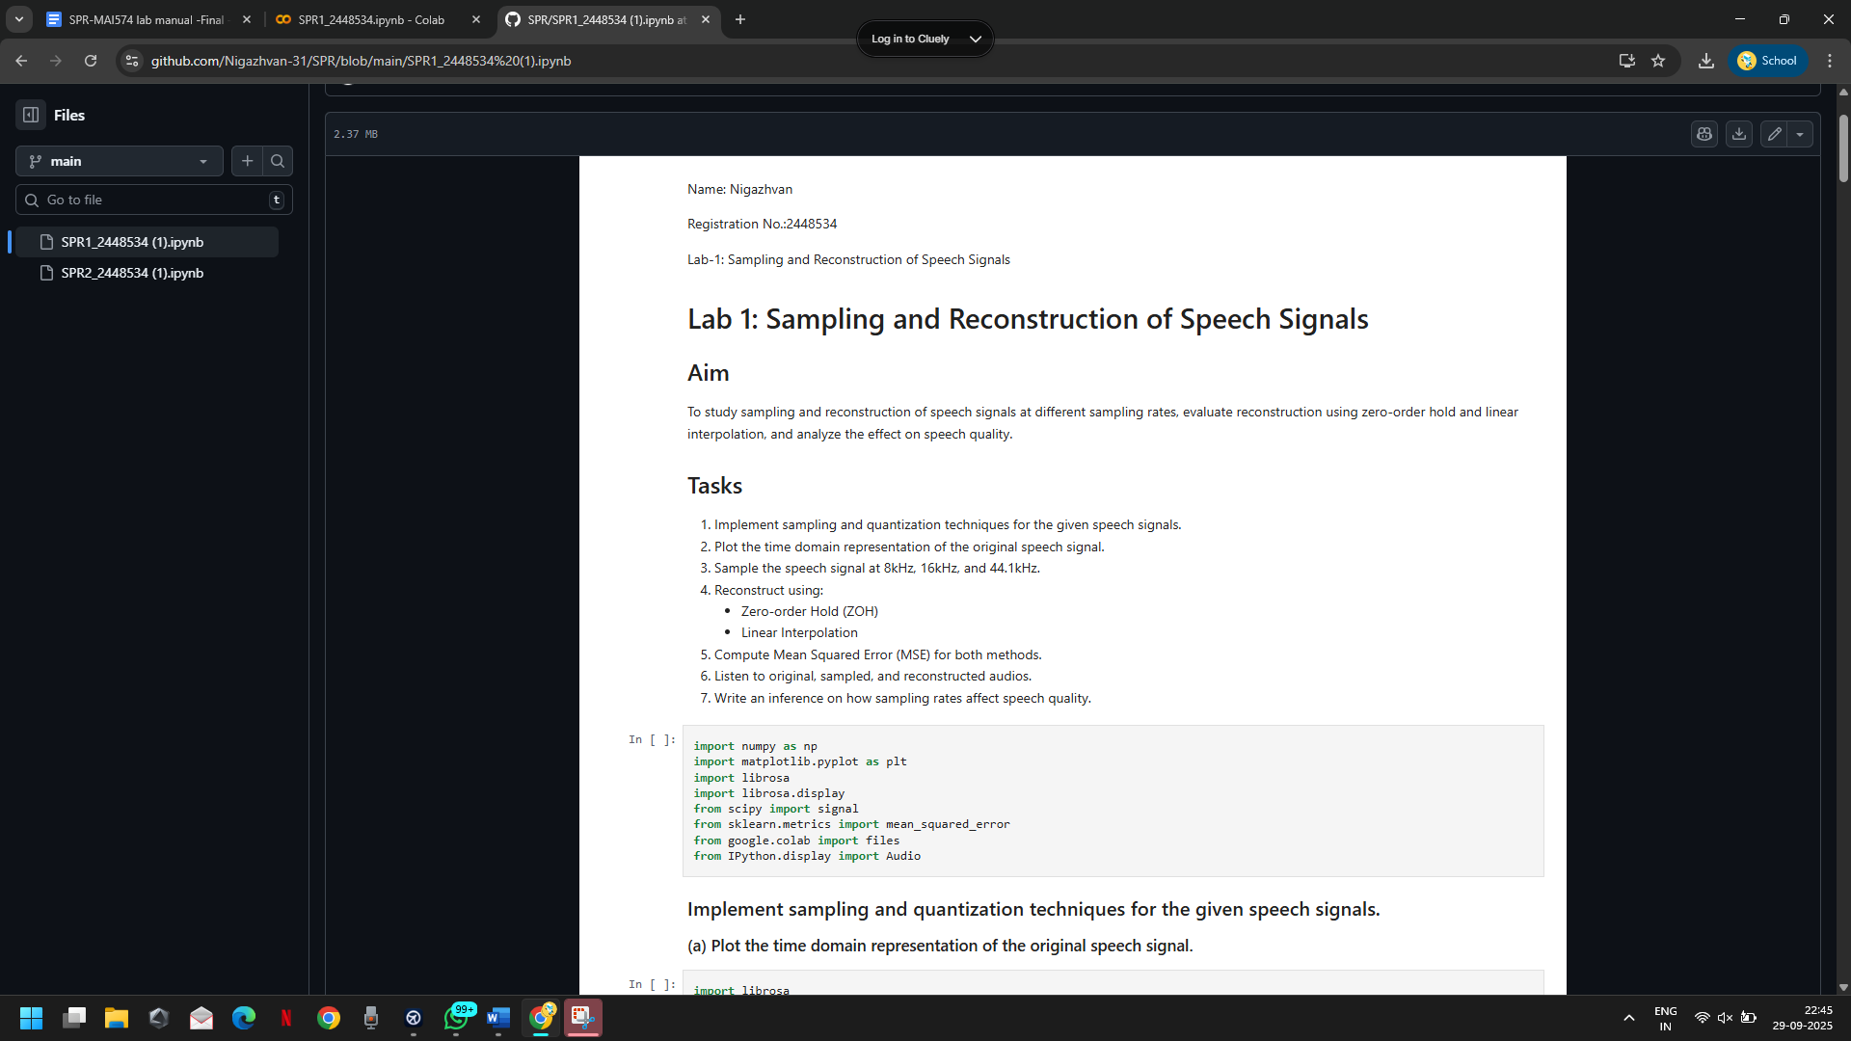

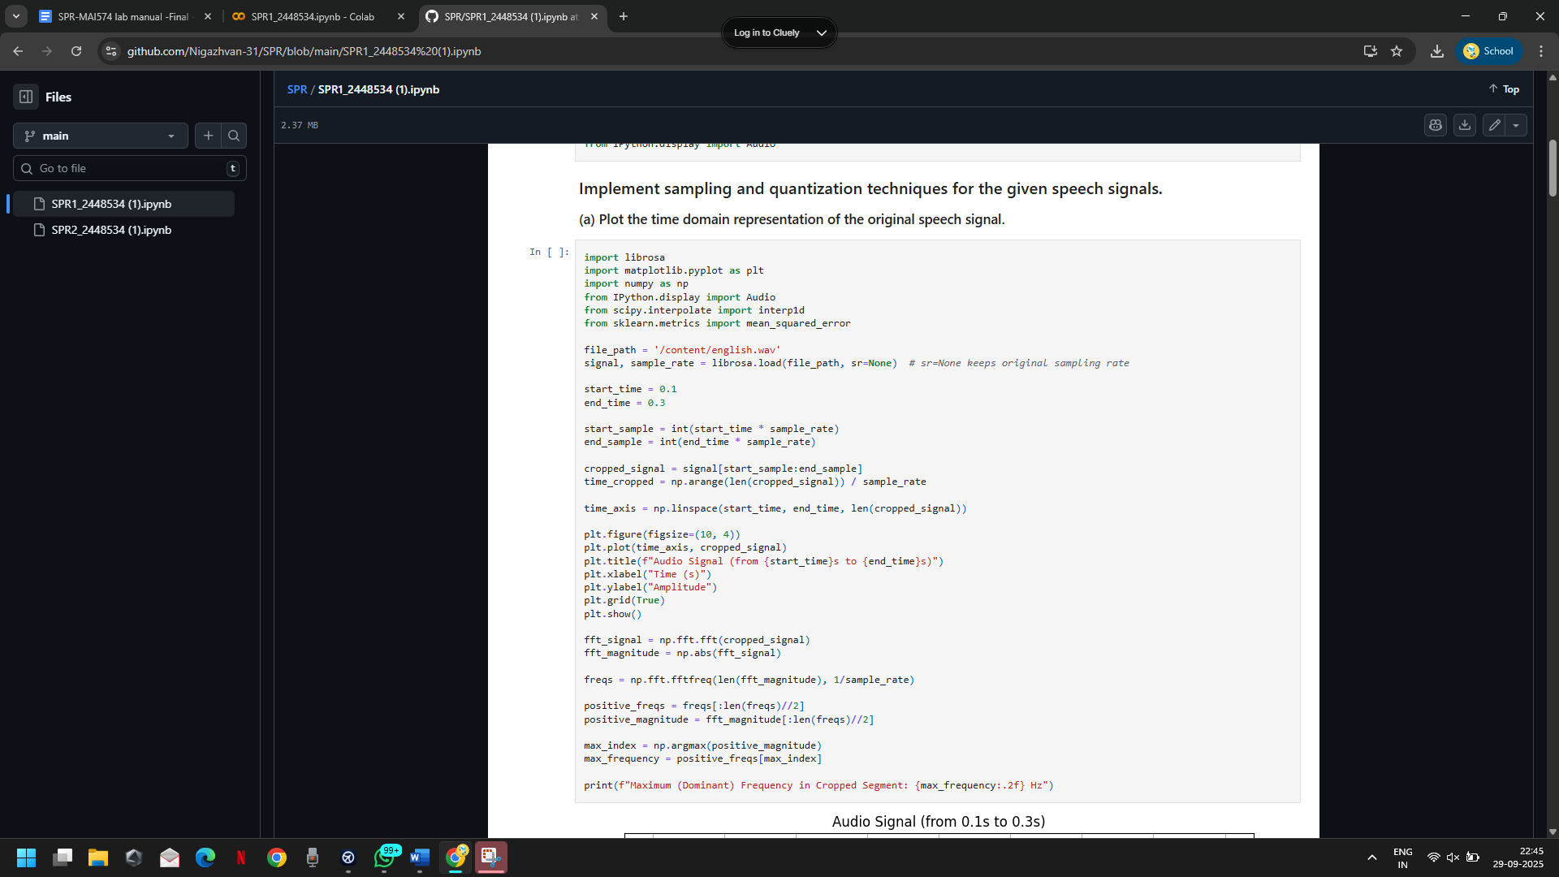

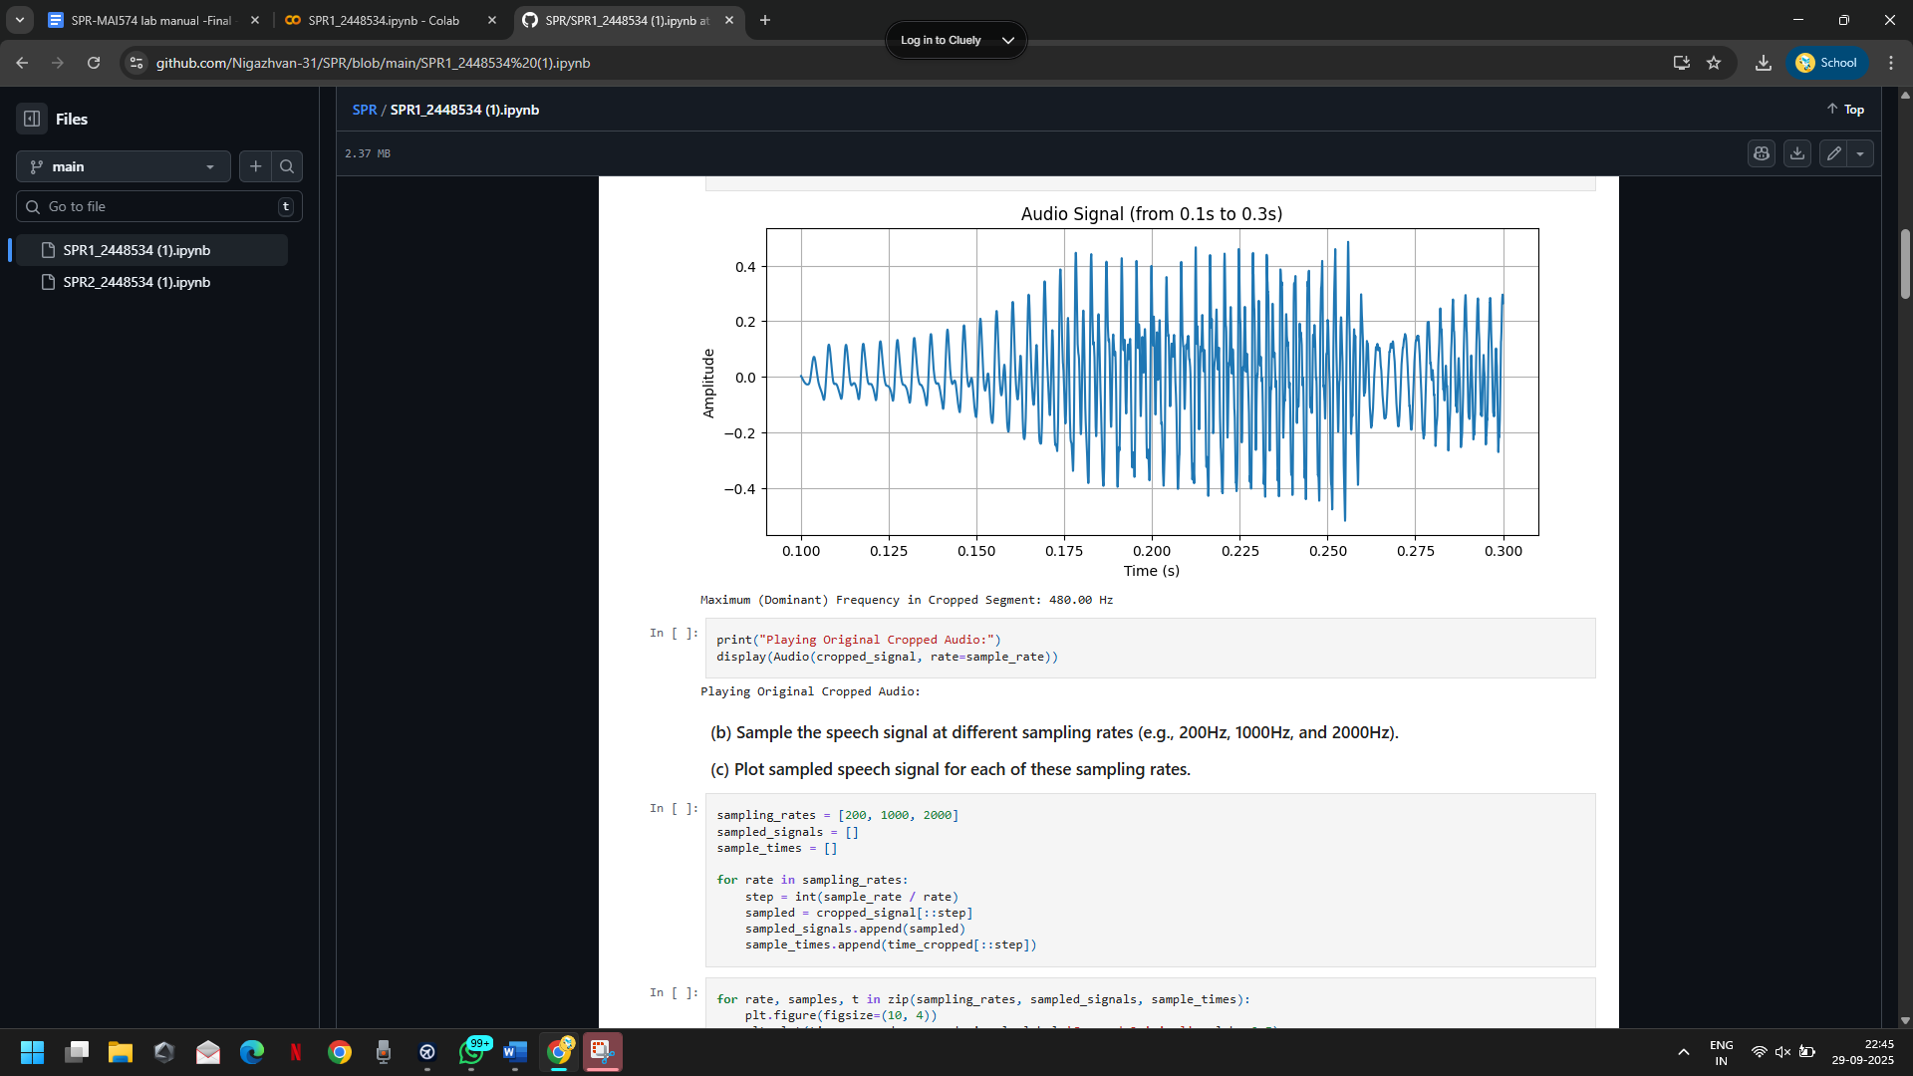

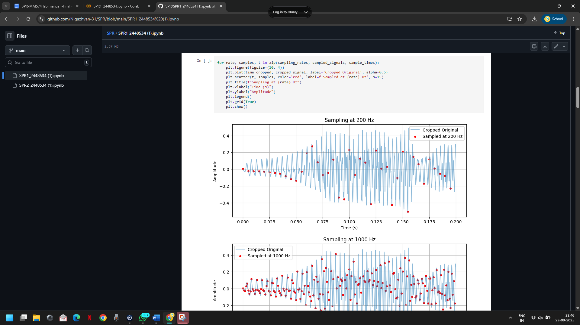

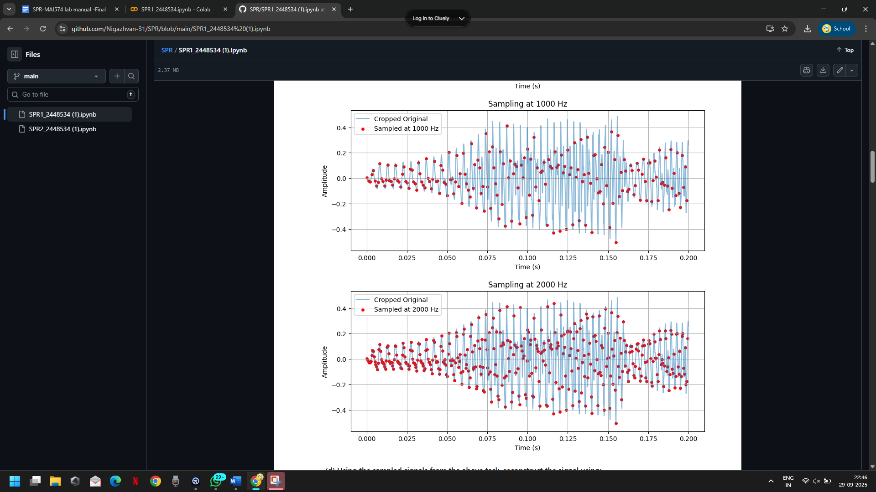

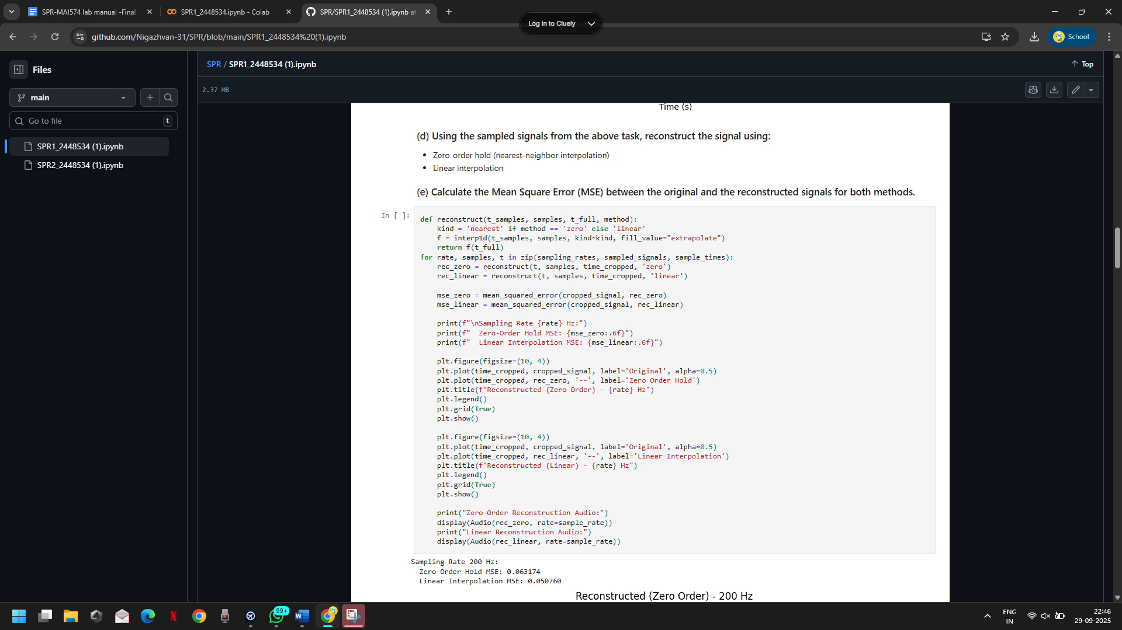

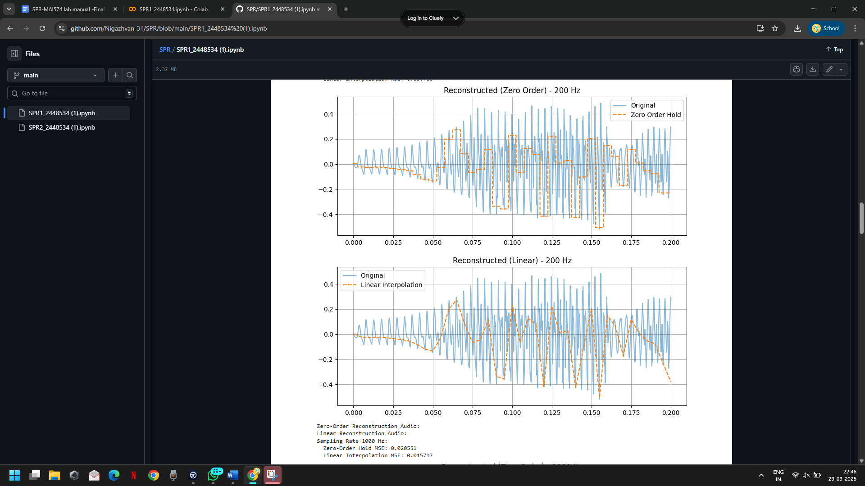

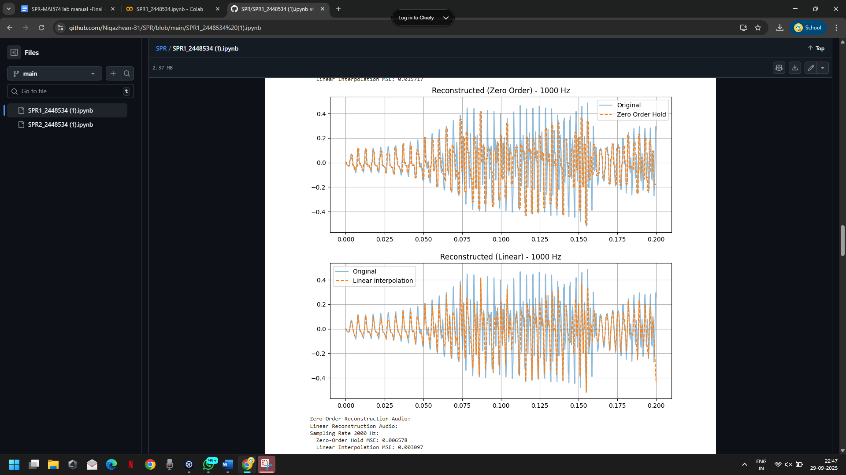

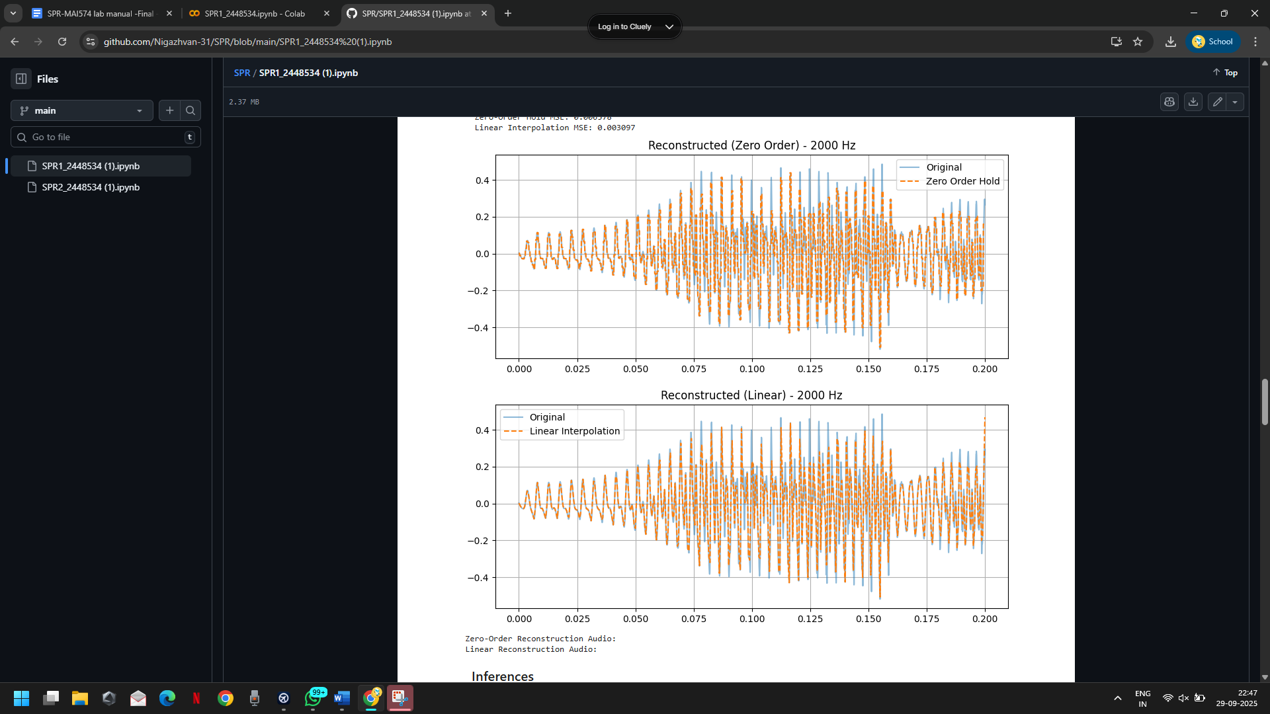

**Conclusion /inference**

**●** The experiment confirms the Nyquist theorem in practice accurate reconstruction is only possible when the sampling rate exceeds twice the highest frequency present in the signal.

● By intentionally sampling below 960 Hz (e.g., 200 Hz), we validated the effect of aliasing and loss of intelligibility, reinforcing the need for adequate sampling rates in speech processing.

**(2) Implement the source-filter model for a given speech signal and analyze the impact of sampling and reconstruction on the quality of the speech signal.**

**Code with Results**

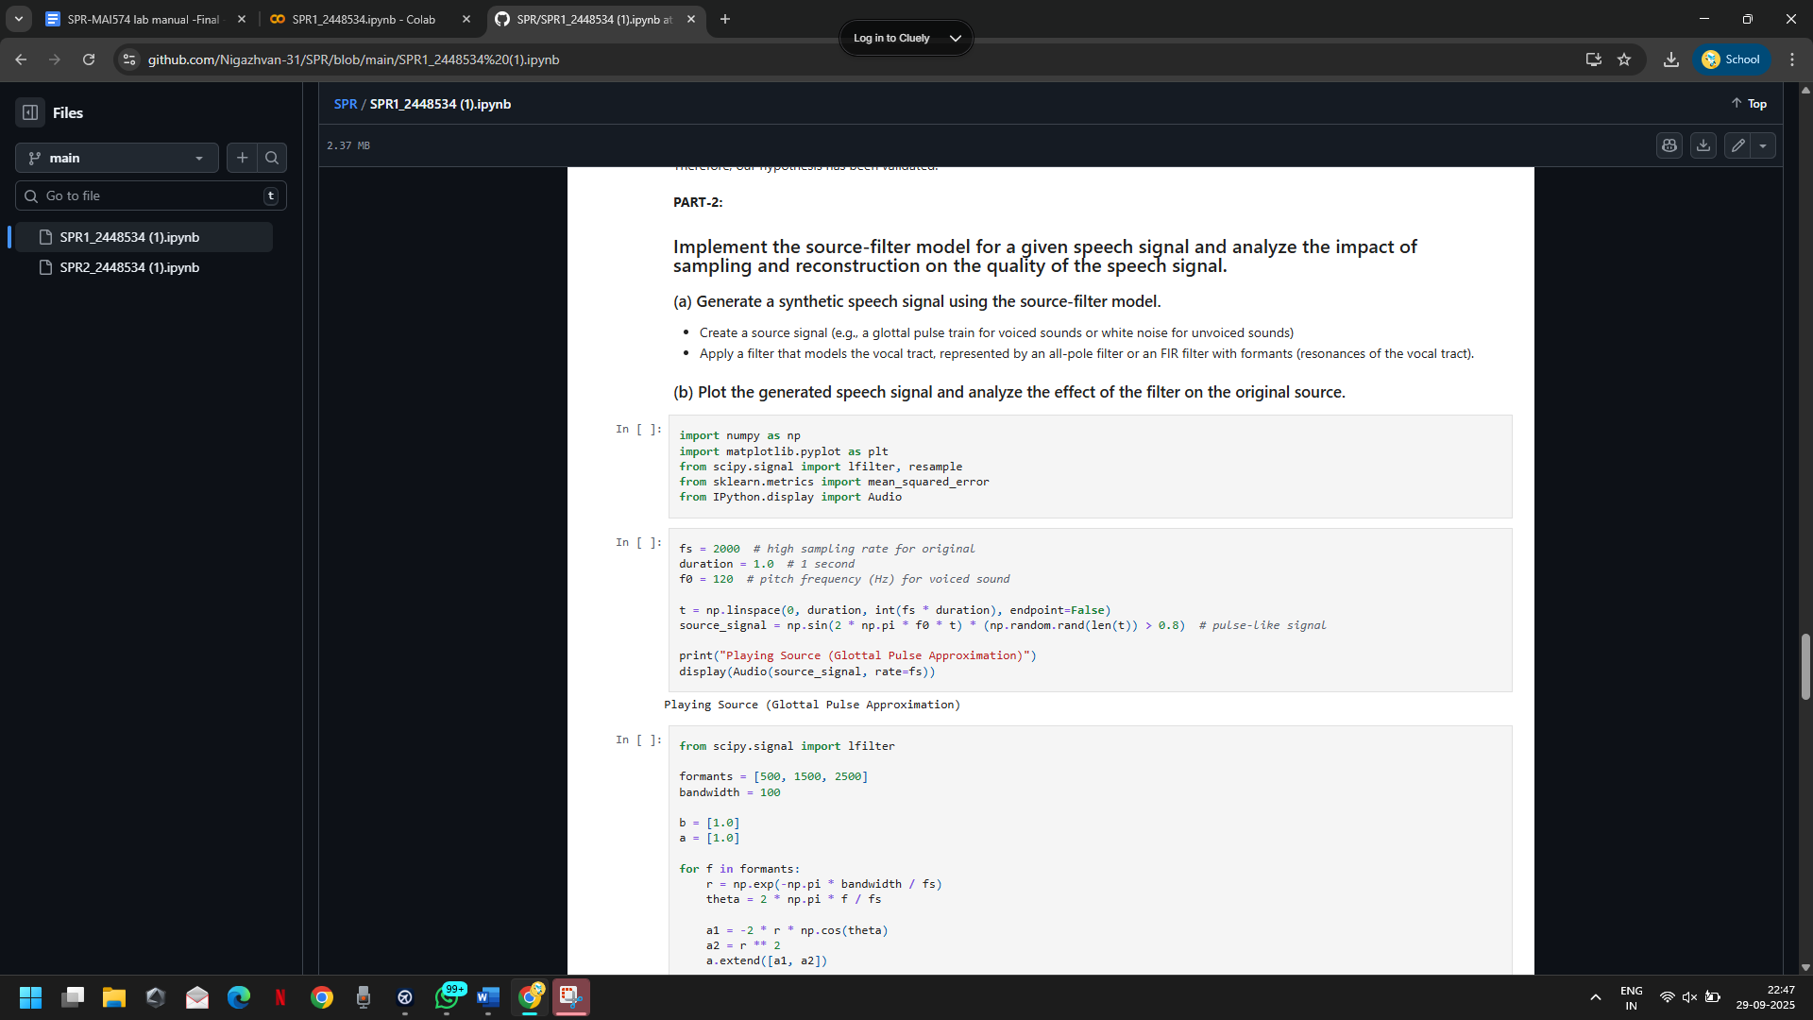

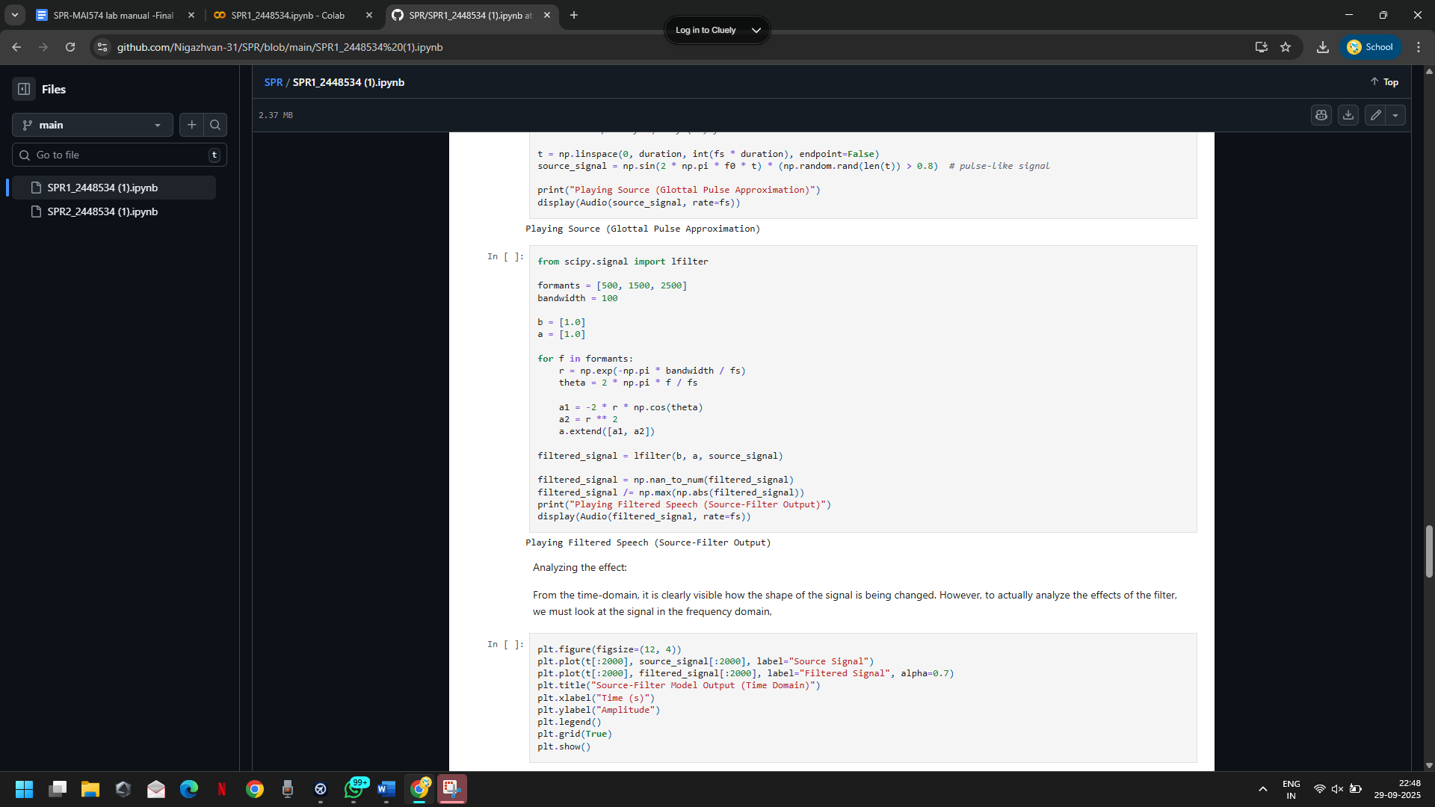

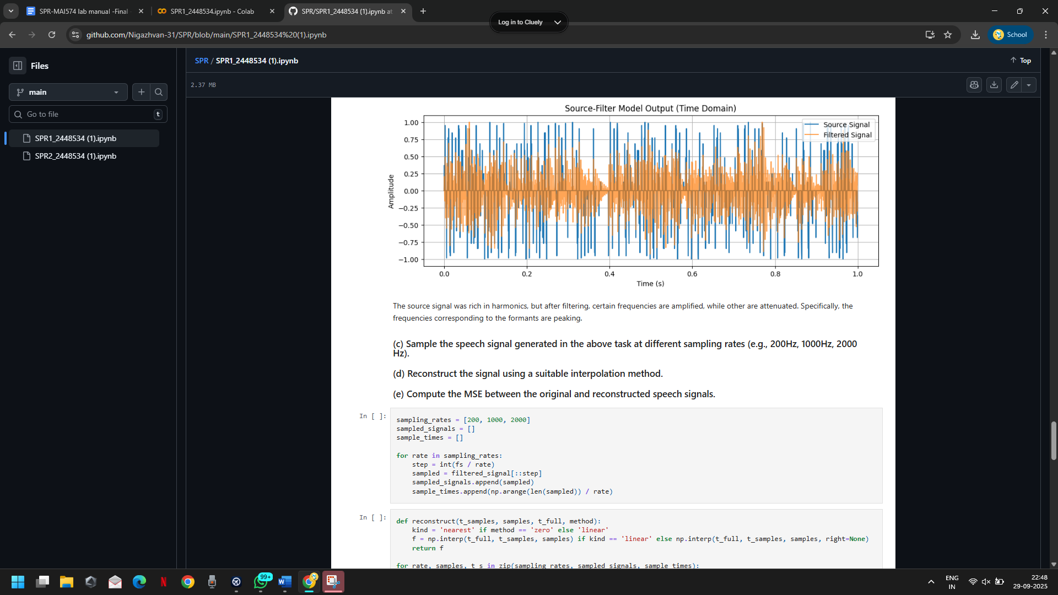

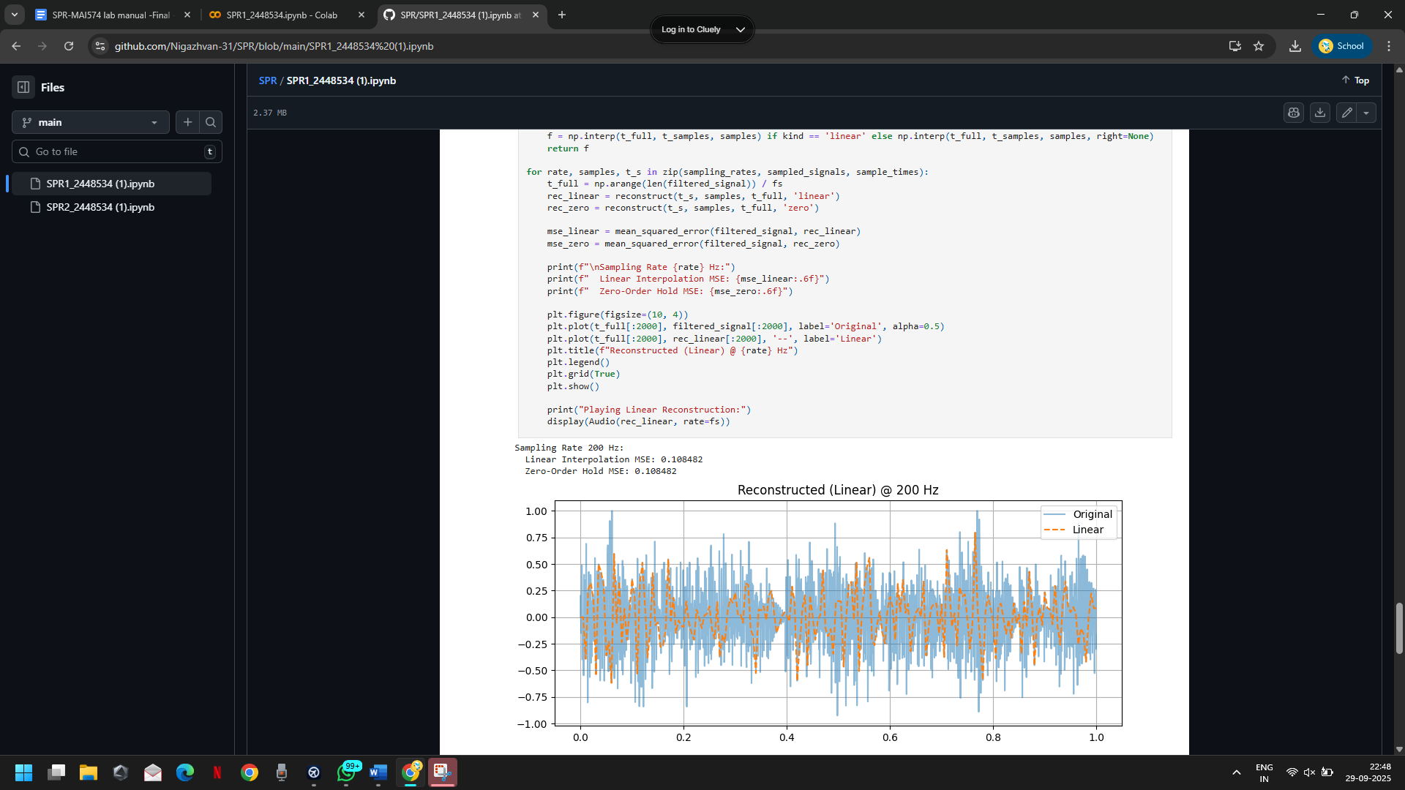

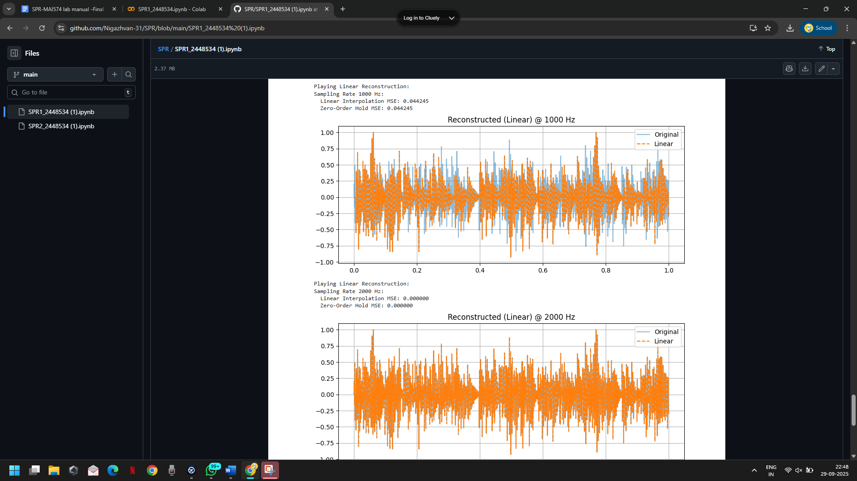

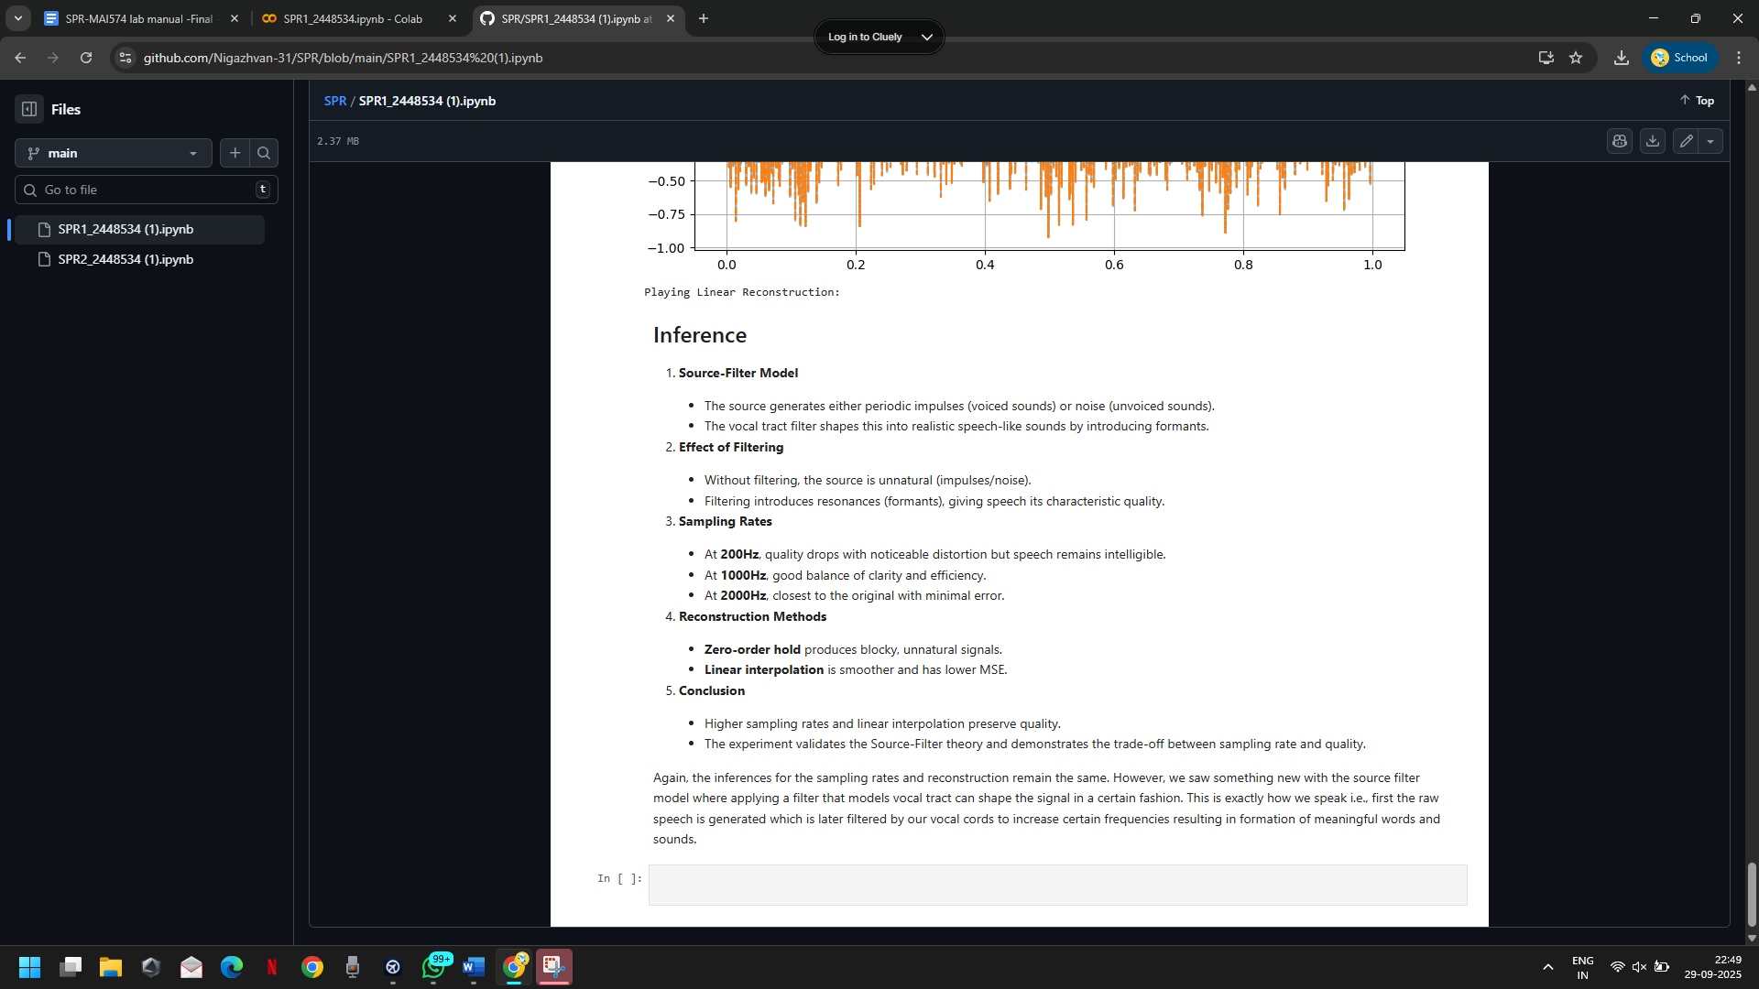

**Conclusion/Inference**

Again, the inferences for the sampling rates and reconstruction remain the same. However, we saw something new with the source filter model where applying a filter that models the vocal tract can shape the signal in a certain fashion. This is exactly how we speak i.e., first the raw speech is generated which is later filtered by our vocal cords to increase certain frequencies resulting in formation of meaningful words and sounds.

## Lab Exercise 2:

## Fourier Transform and Frequency Spectrum Analysis of Signals

### **Aim**

To study the Fourier Transform and analyze the frequency spectrum of different signals (sinusoidal, composite, exponential, and rectangular). To compare their time-domain representation with their frequency-domain characteristics using both the Discrete-Time Fourier Transform (DTFT) and the Discrete Fourier Transform (DFT).

**Questions**

**Question 1** (a) Generate a basic sinusoidal signal in the time domain. (For example, generate a sine wave with a frequency of 5 Hz, sampled at 1000 Hz.)  
 (b) Plot the time-domain waveform of the signal.  
 (c) Compute the Discrete-Time Fourier Transform (DTFT) and plot the continuous frequency spectrum.  
 (d) Compute the Discrete Fourier Transform (DFT) and plot the discrete frequency spectrum.

**Question 2** (a) Generate a composite signal by adding two or more sinusoidal signals of different frequencies and amplitudes.  
 (b) Plot the time-domain waveform of the composite signal.  
 (c) Compute the Discrete-Time Fourier Transform (DTFT) and plot the continuous frequency spectrum.  
 (d) Compute the Discrete Fourier Transform (DFT) and plot the discrete frequency spectrum.

**Question 3** (a) Generate an exponentially decaying signal.  
 (b) Plot the time-domain waveform.  
 (c) Compute the Discrete-Time Fourier Transform (DTFT) and plot the continuous frequency spectrum.  
 (d) Compute the Discrete Fourier Transform (DFT) and plot the discrete frequency spectrum.  
 (e) Analyze the relationship between the time-domain waveform and the frequency-domain representation.

**Question 4** (a) Generate a **rectangular pulse signal** of finite duration in the time domain.  
 (b) Plot the time-domain waveform.  
 (c) Compute the Discrete-Time Fourier Transform (DTFT) and plot the continuous frequency spectrum.  
 (d) Compute the Discrete Fourier Transform (DFT) and plot the discrete frequency spectrum.  
 (e) Analyze the relationship between the time-domain waveform and the frequency-domain representation.

**Evaluation Rubrics**

1. Implementation: 5 marks

2. Complexity and Validation: 3 marks

3. Documentation & Writing the inference: 2 marks

**Submission Guidelines**

● Prepare a single PDF containing answers for all questions with proper plots, results, and inferences.

● Each answer must include Python/Matlab code, output plots, and a conclusion.

● Title the file as: Lab_2_<YourName_RegNo>.

● Upload the PDF to Google Classroom before the deadline.

● Maintain a Git repository with separate branches for each lab (Lab1, Lab2, …). Push your code and include the repo link in your submission.

**Question 1:**

**Code with results:**

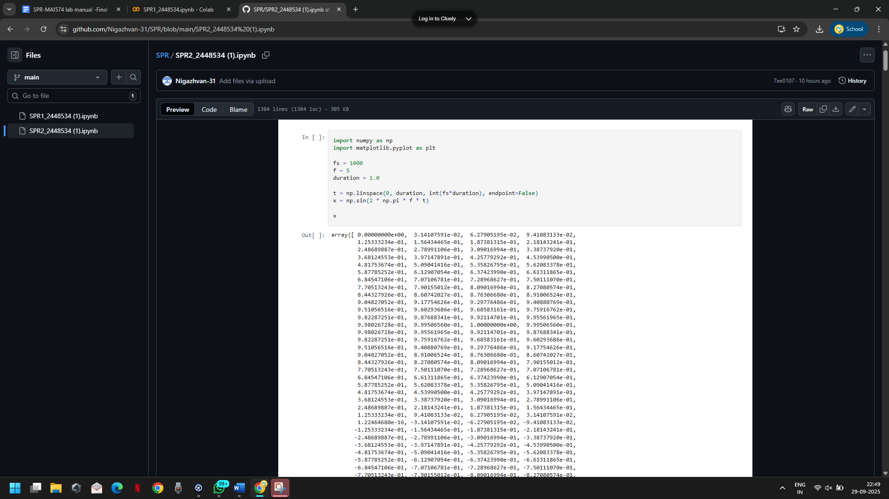

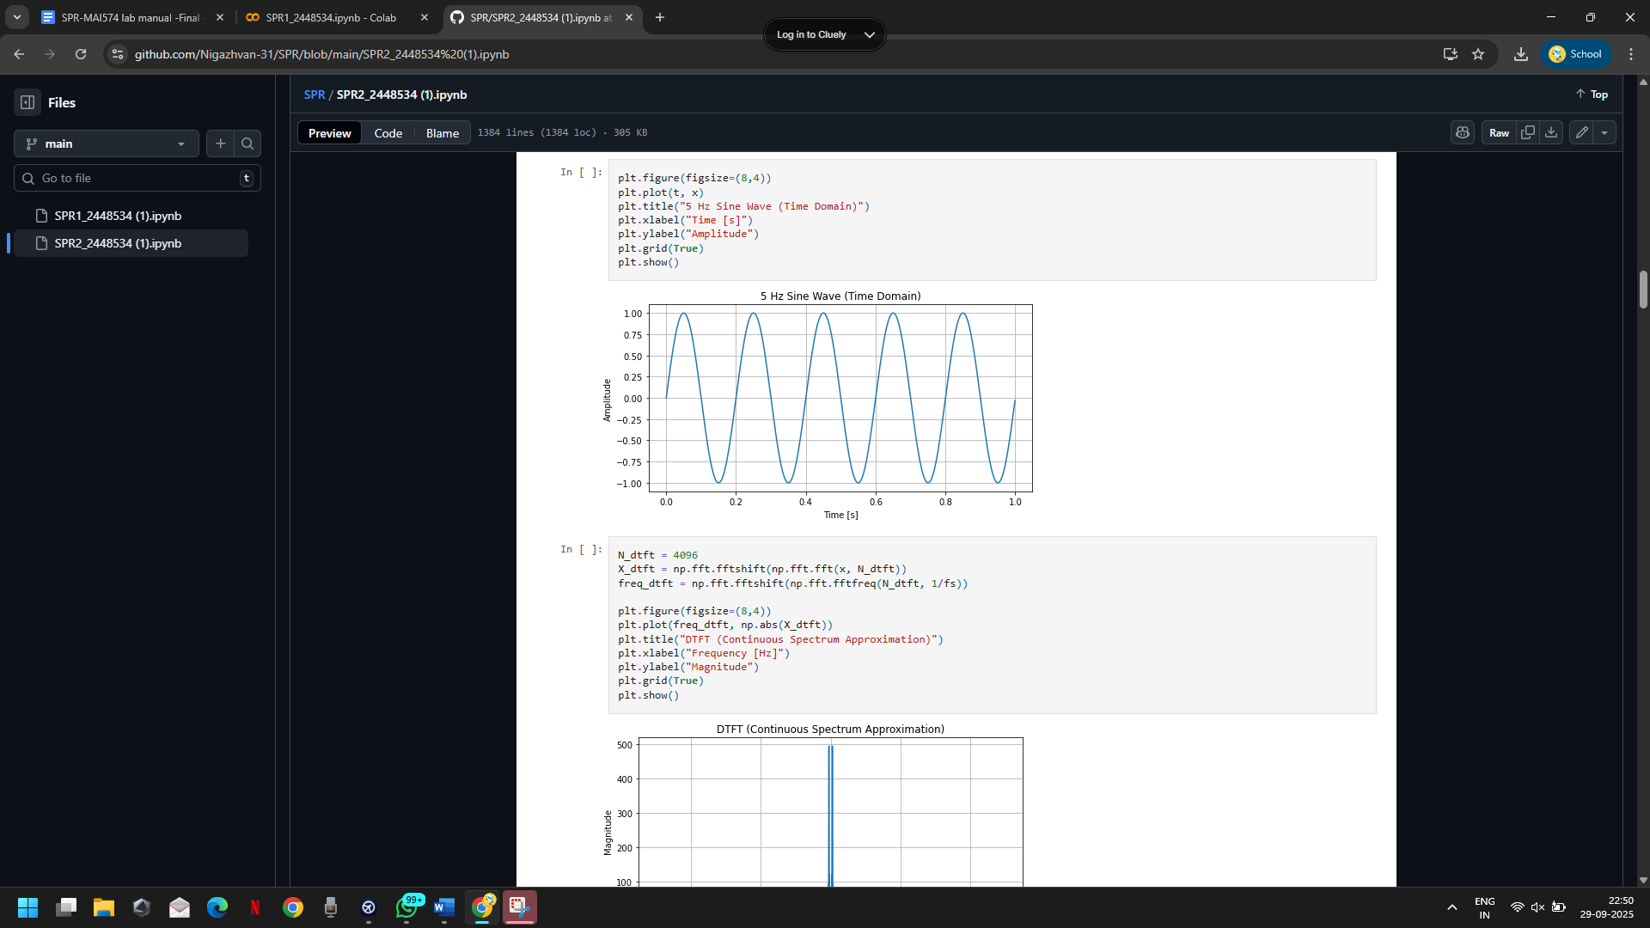

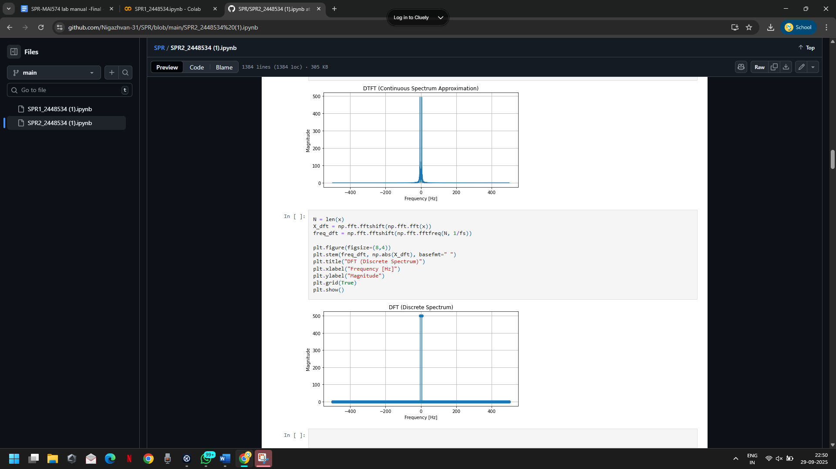

**Question 2:**

**Code with results:**

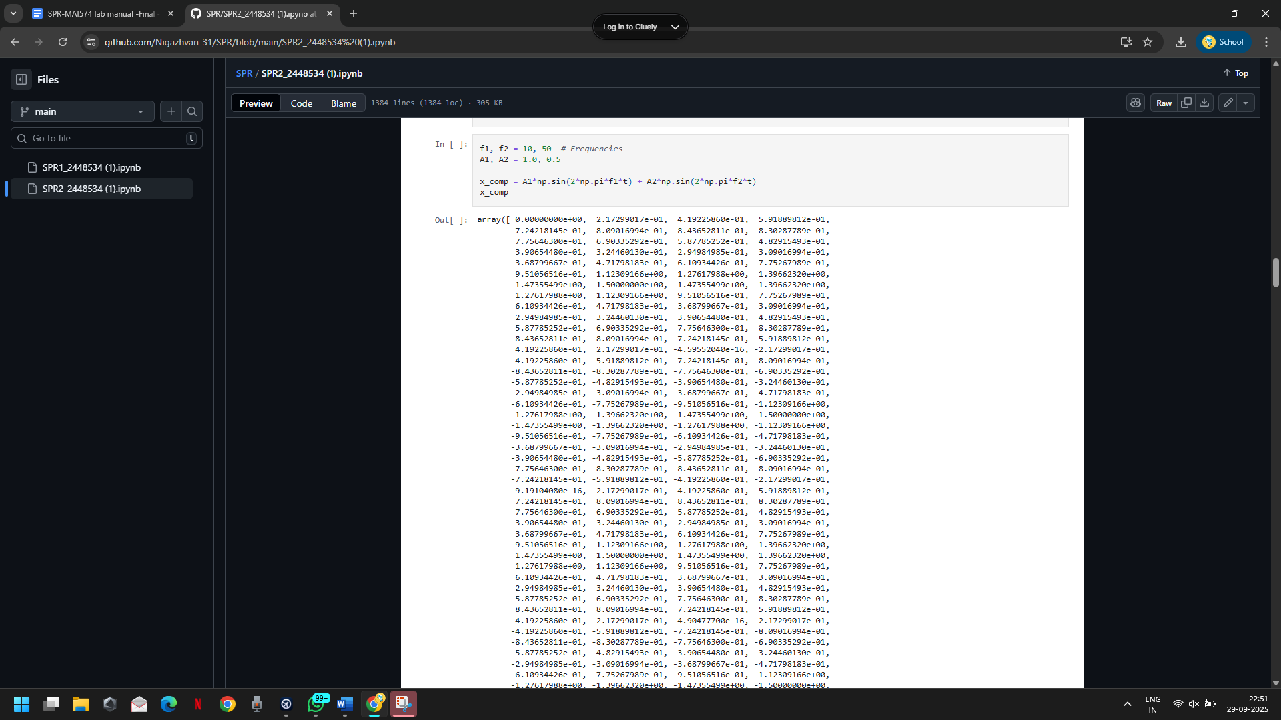

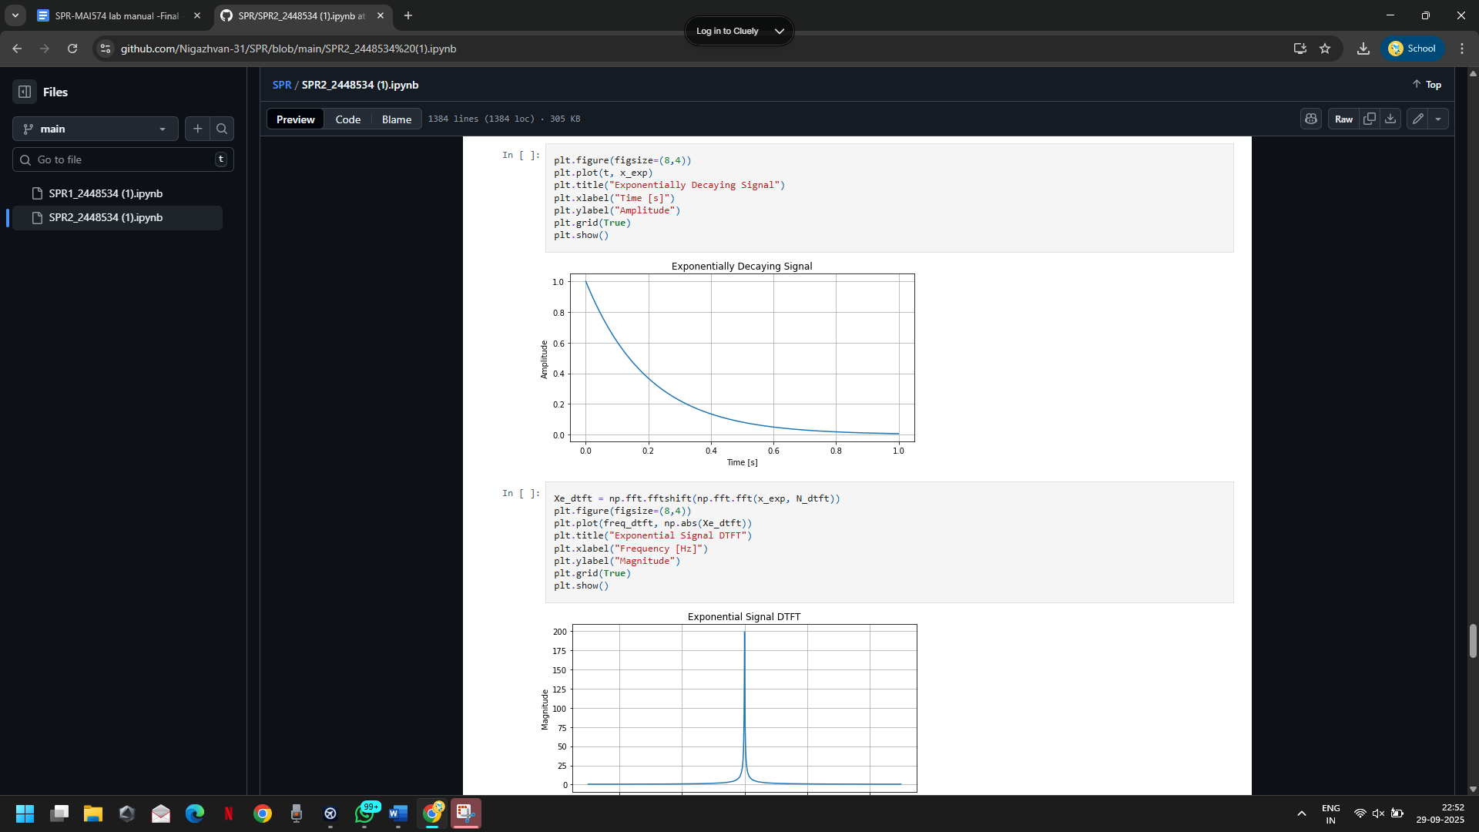

**Question 3:**

**Code with results:**

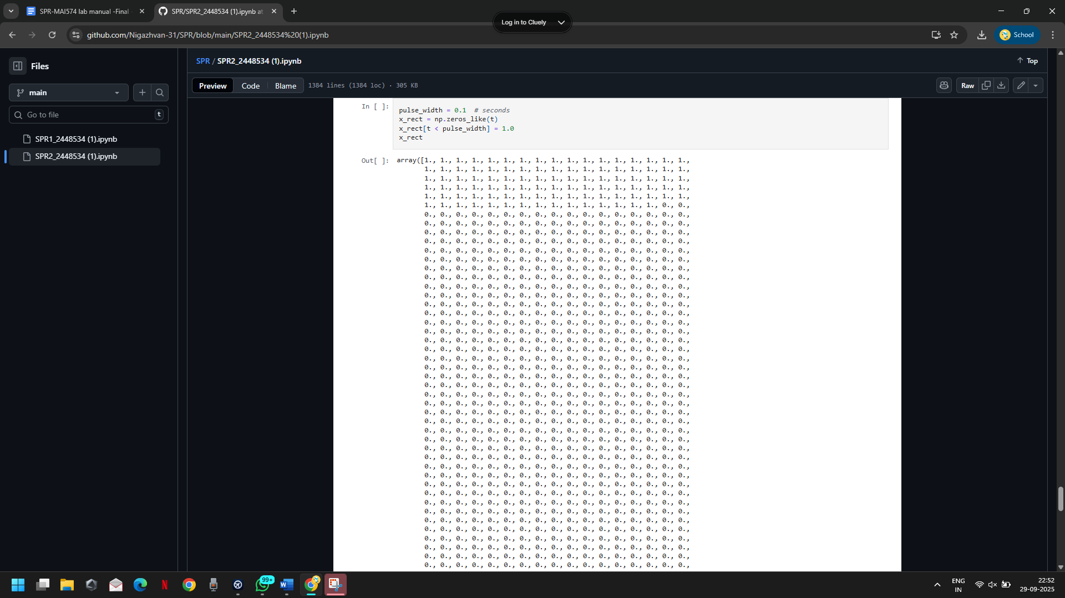

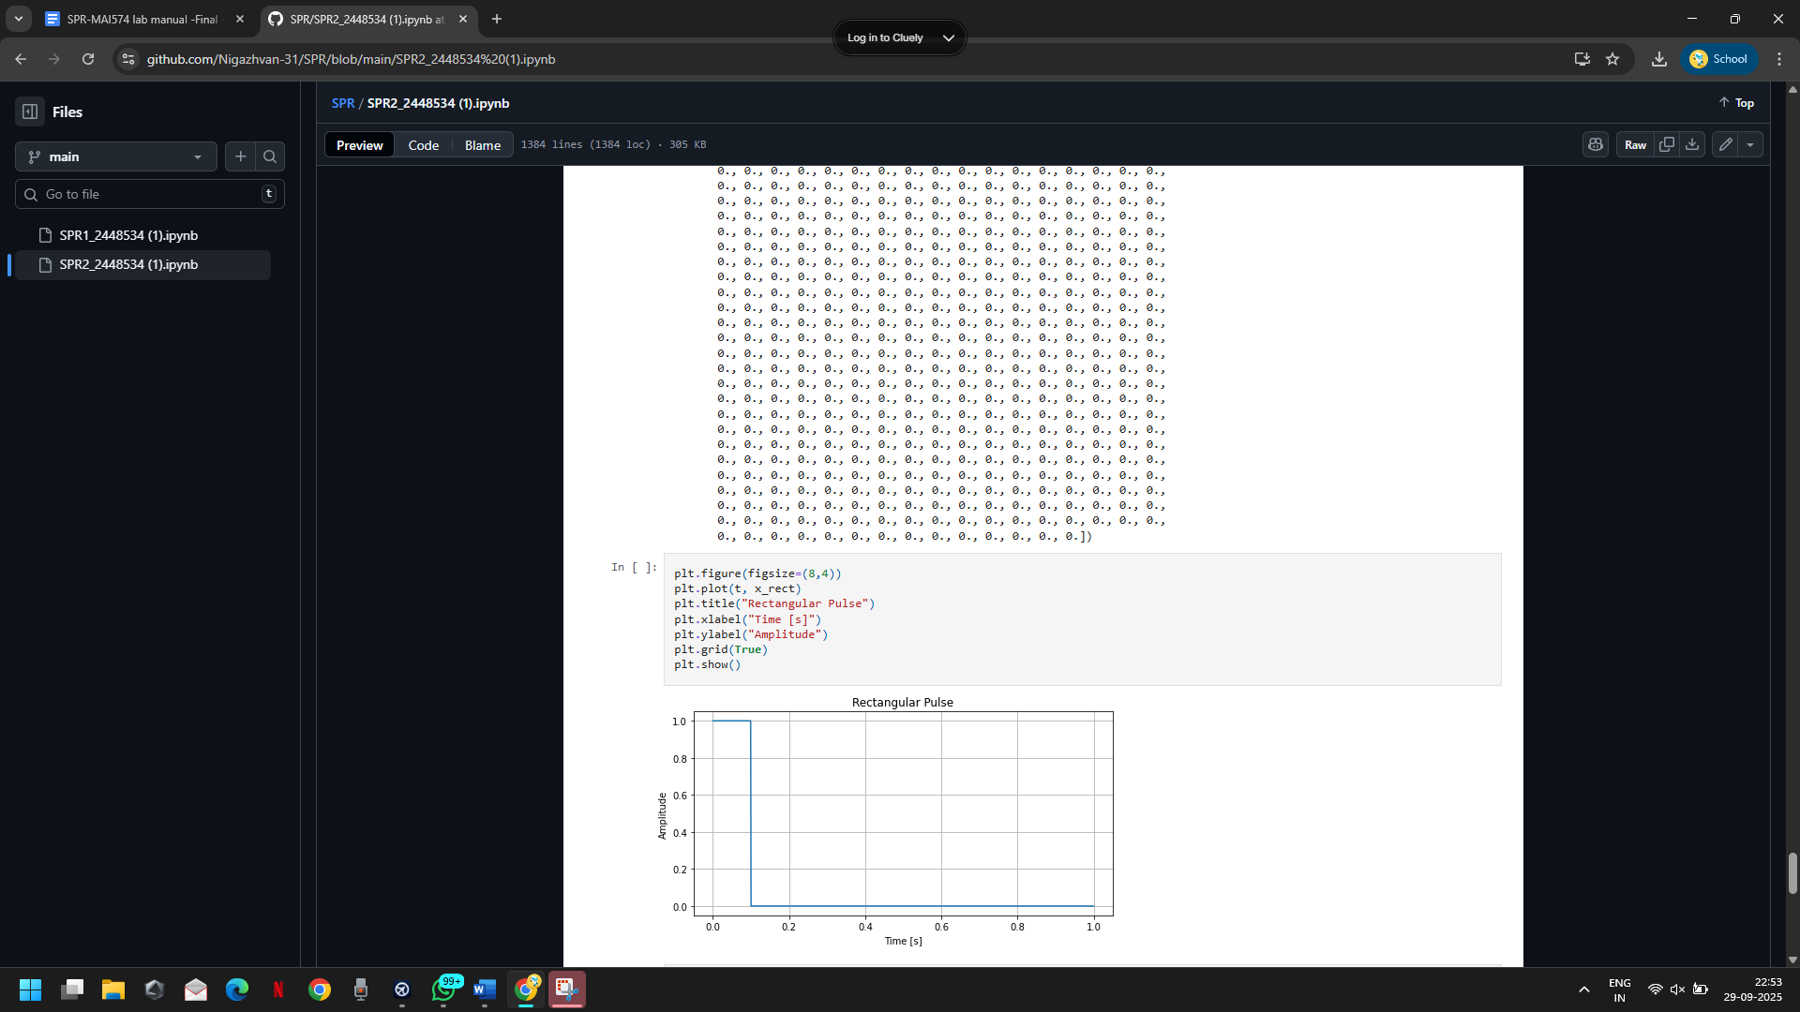

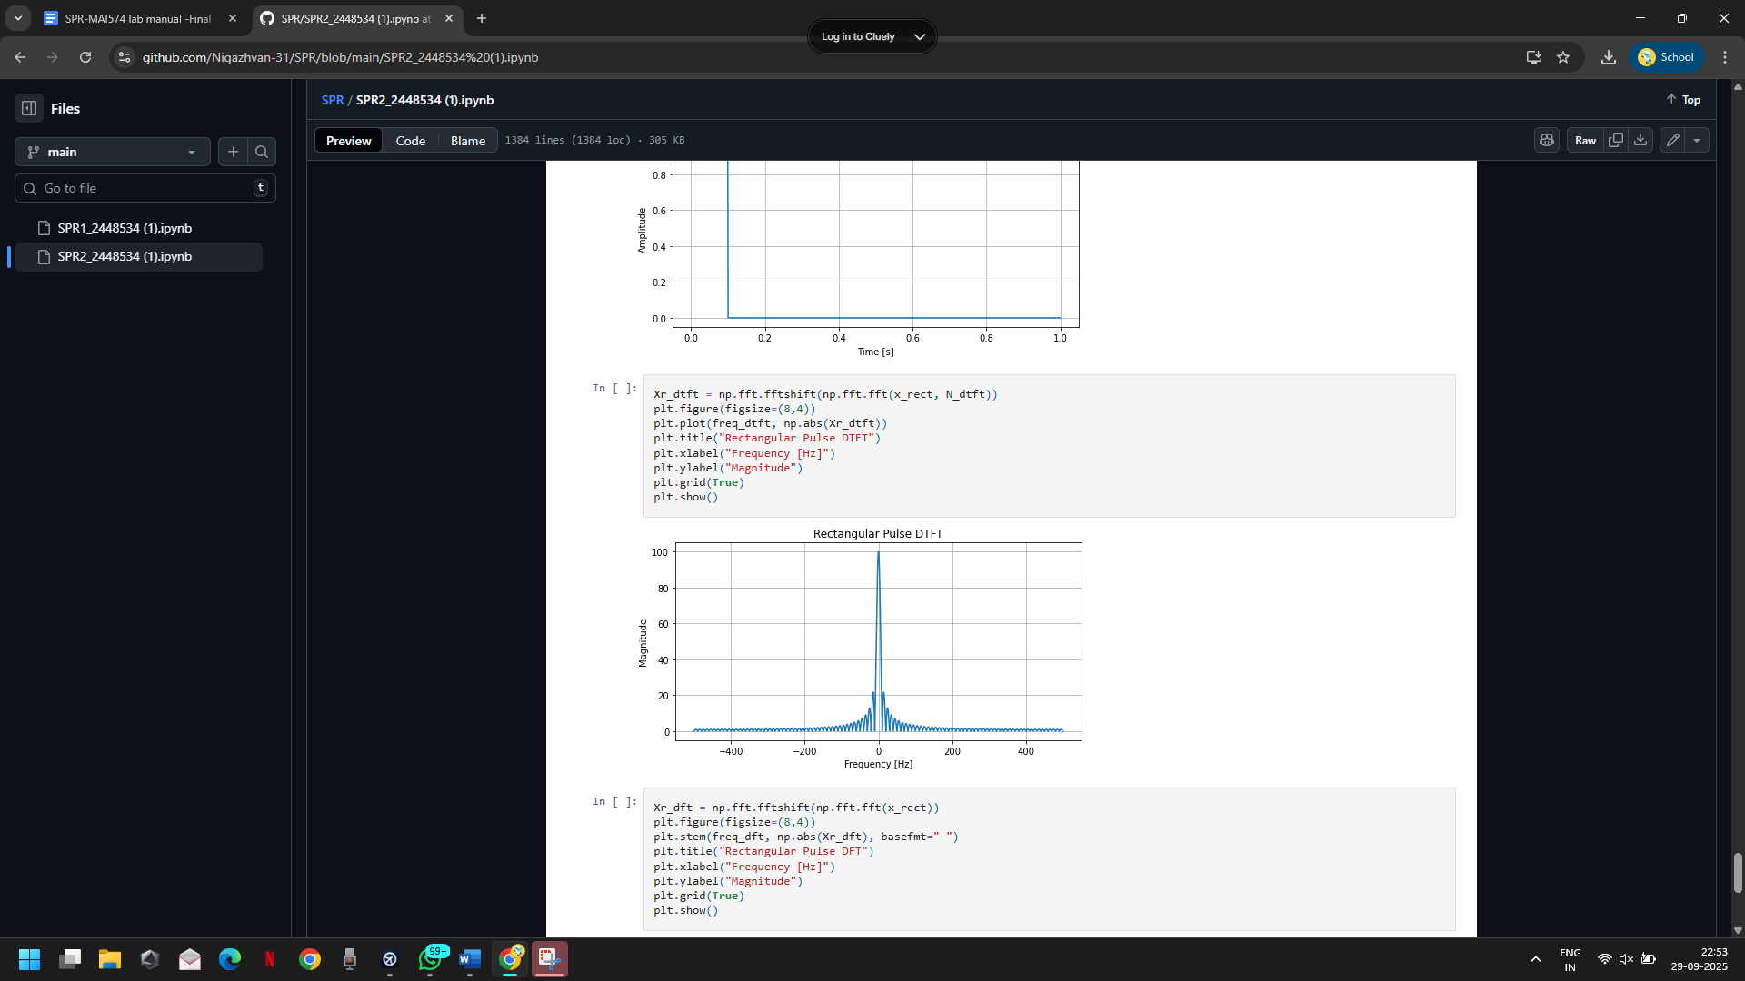

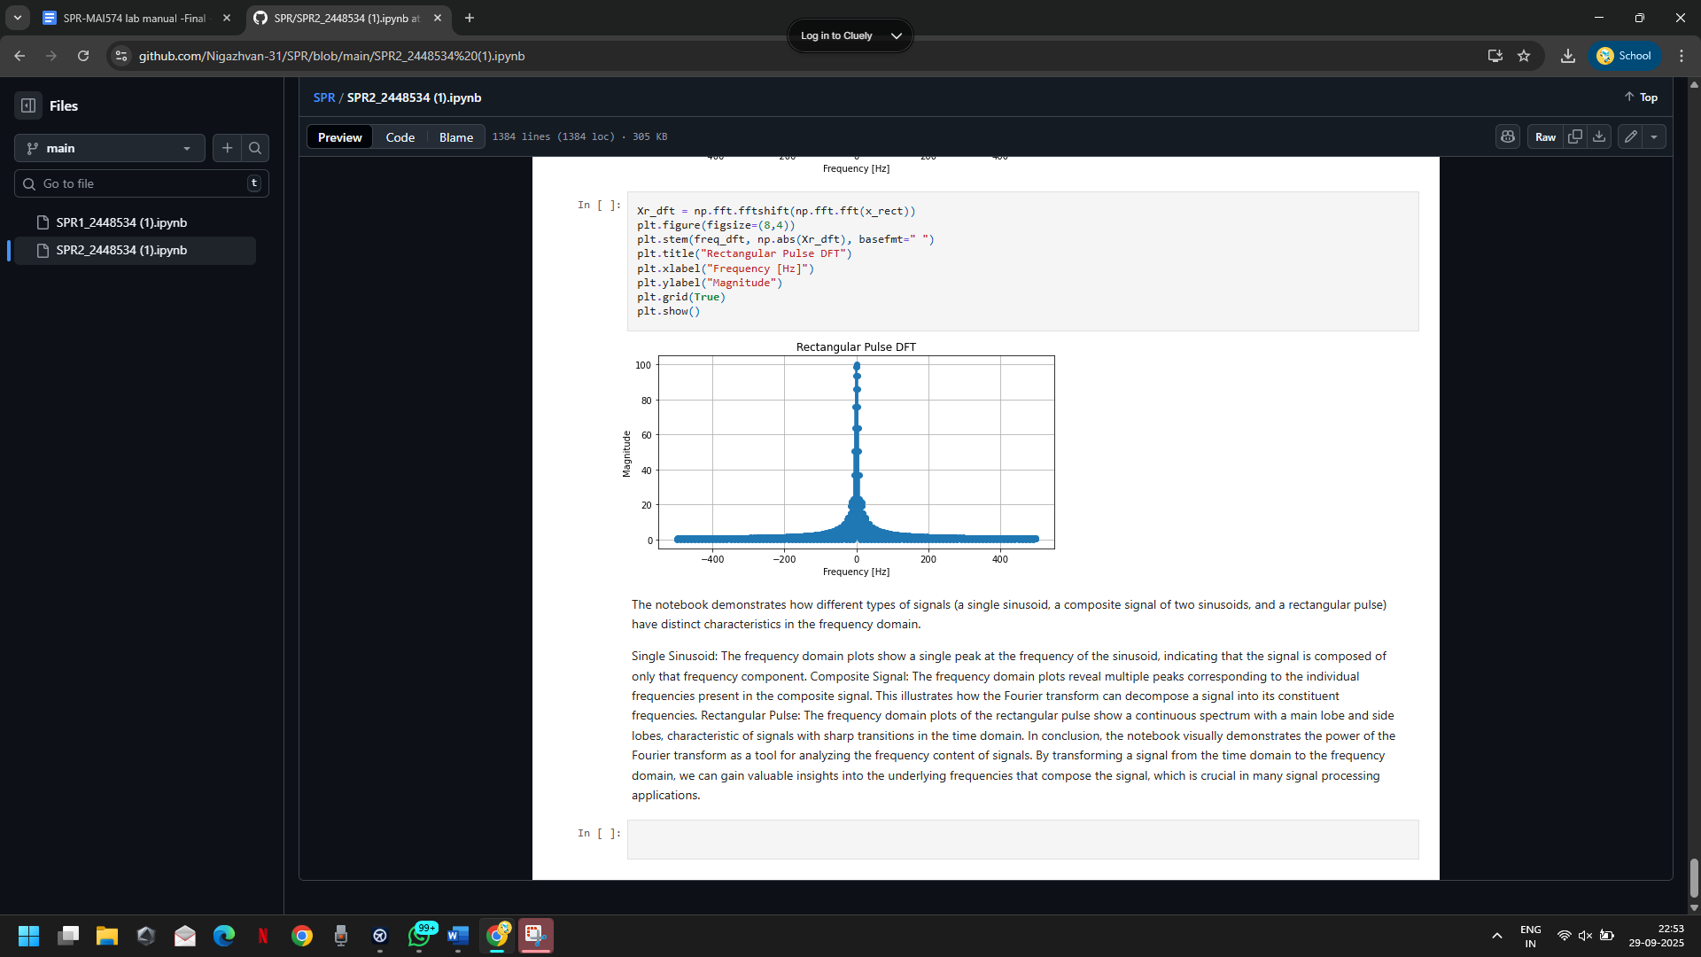

**Conclusion/Inference:**

The frequency domain analysis reveals that a single-frequency sine wave is purely a single tone with no other frequency components. The energy is concentrated entirely at the specific frequency of the sine wave. The frequency spectrum of a multiple-frequency sinusoidal wave clearly indicates the presence of multiple distinct tones. The frequency domain provides an intuitive understanding of how each frequency contributes to the overall signal. The frequency spectrum of an exponentially decaying signal indicates that the signal contains a wide range of frequency components. The broad spectrum reflects the rapid changes in the signal as it decays, indicating a mixture of low and high-frequency content.

The frequency domain analysis of an aperiodic rectangular signal reveals a complex and broad frequency spectrum. The absence of periodicity in the time domain leads to a continuous spread of energy across frequencies, and the DFT highlights the non-repetitive nature of the signal.